**DBST670 Oracle 12c Installation steps**



Connect to your work space above using the link: [https://login.daas.umuc.edu](https://login.daas.umuc.edu/)

Open the “UMUC Labs” tool and find your course listed (i.e., DBST670).

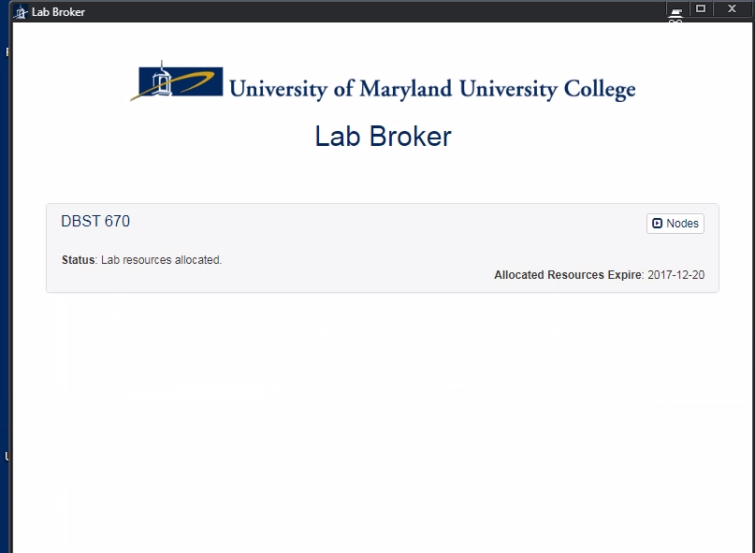

Select the “Nodes” button. If your lab is not allocated, you must first allocate to access the lab.

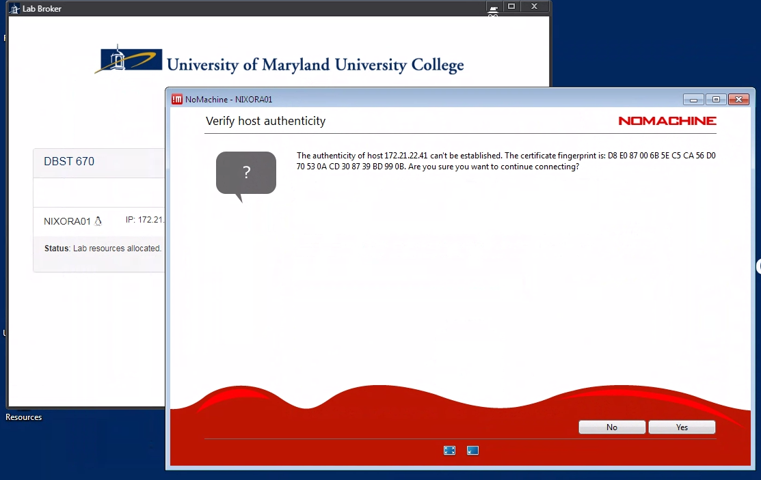

Select “Connect” to begin the NoMachine GUI connection and click Ok.

**NoMachine GUI Connection**

|  |  |
| --- | --- |
| **Username:** | StudentFirst |
| **Password:** | Cyb3rl@b |
| **Privileges:** | sudo |

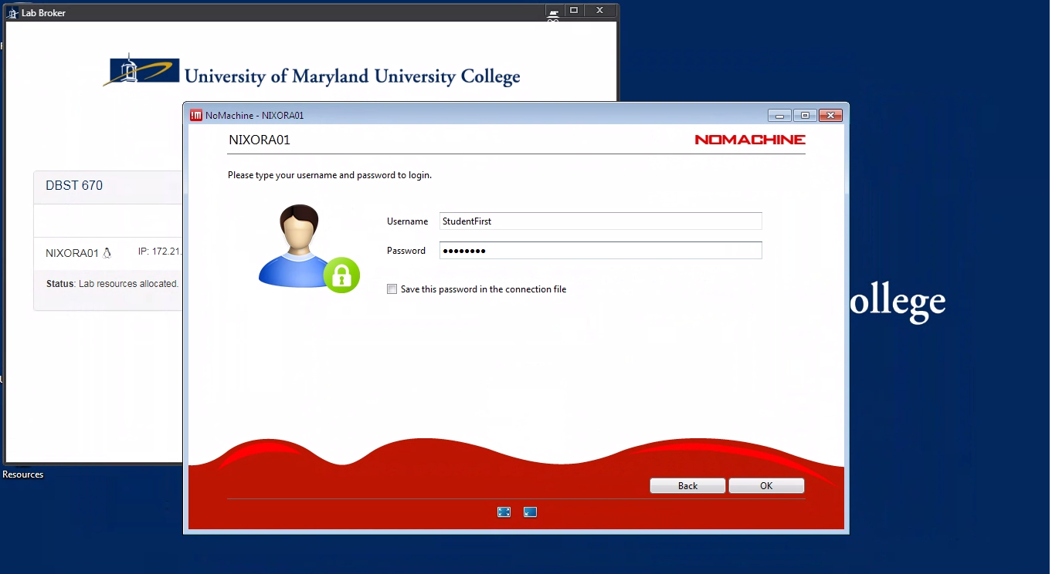

Use the “StudentFirst” Credentials above for the initial login. You may then switch users as needed.

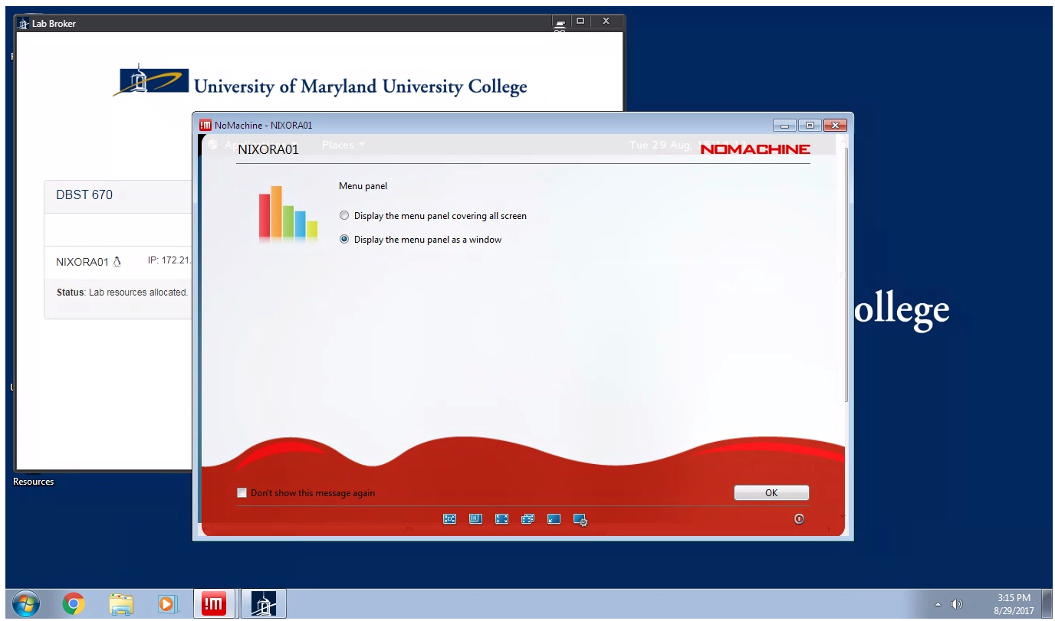

Select the “Display the menu panel as a window”, and click OK

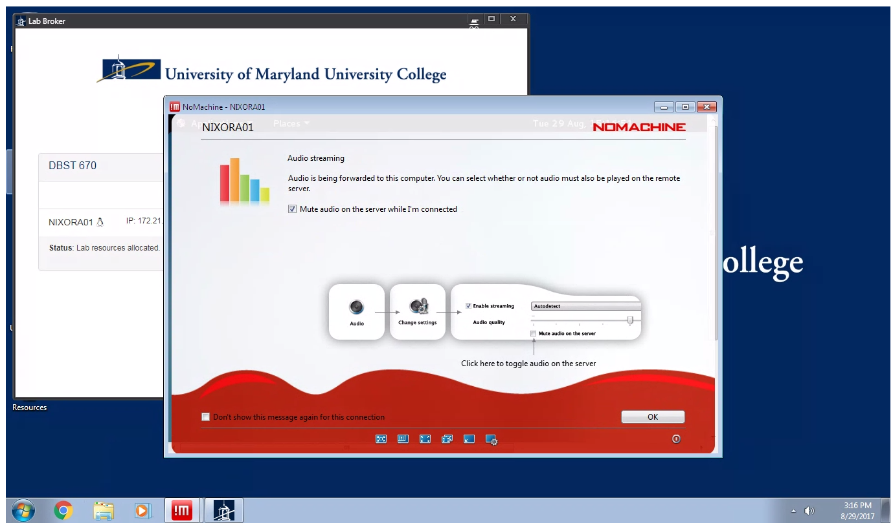

Select “Mute audio on the server while I am connected”, and click Ok to continue

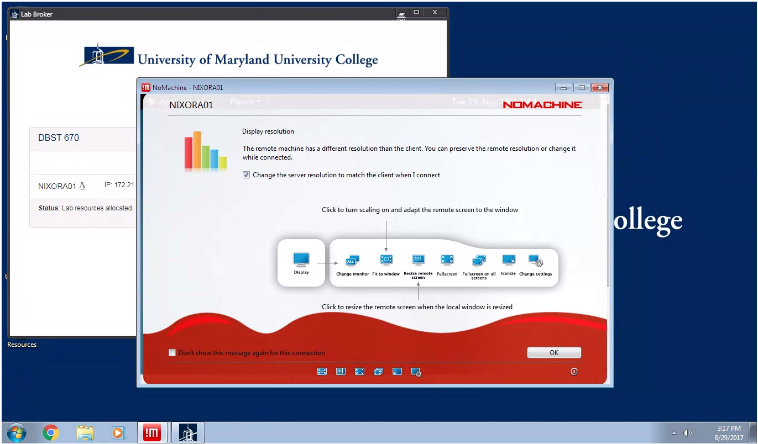

Select “Change the server resolution to match the client when connected”, and click OK to continue.

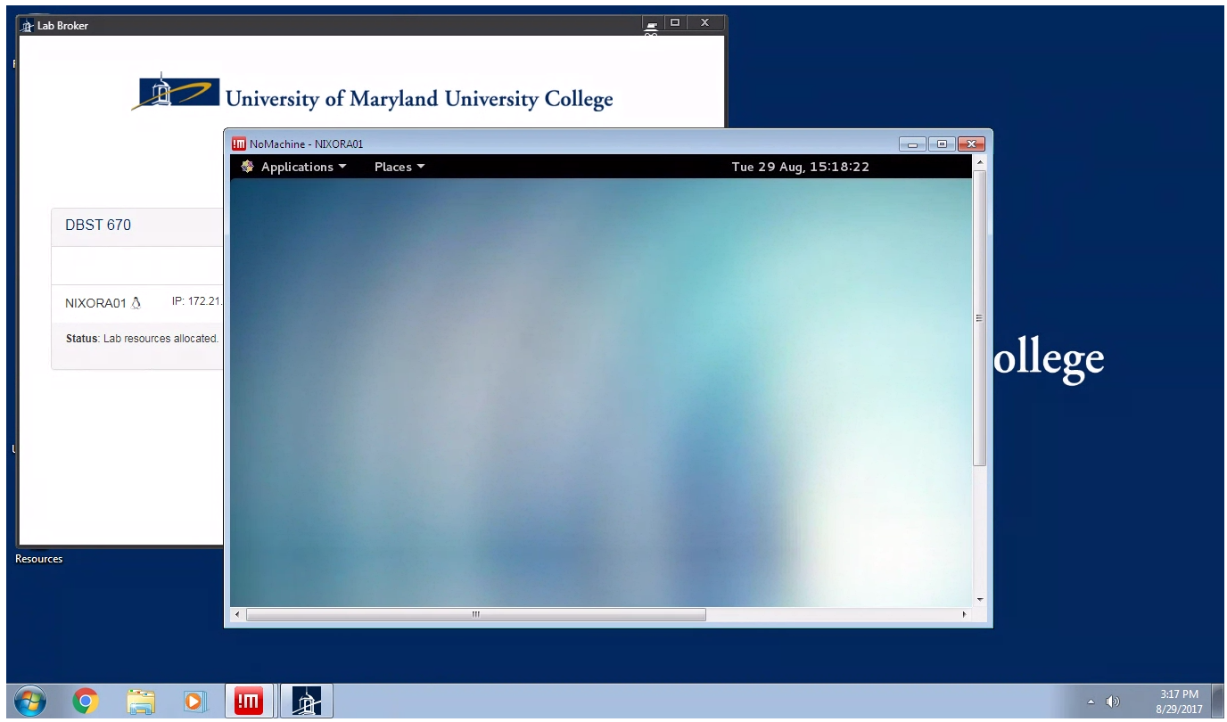

Now you have the window as shown above.

Select the Application-🡪 Favorites🡪Terminal

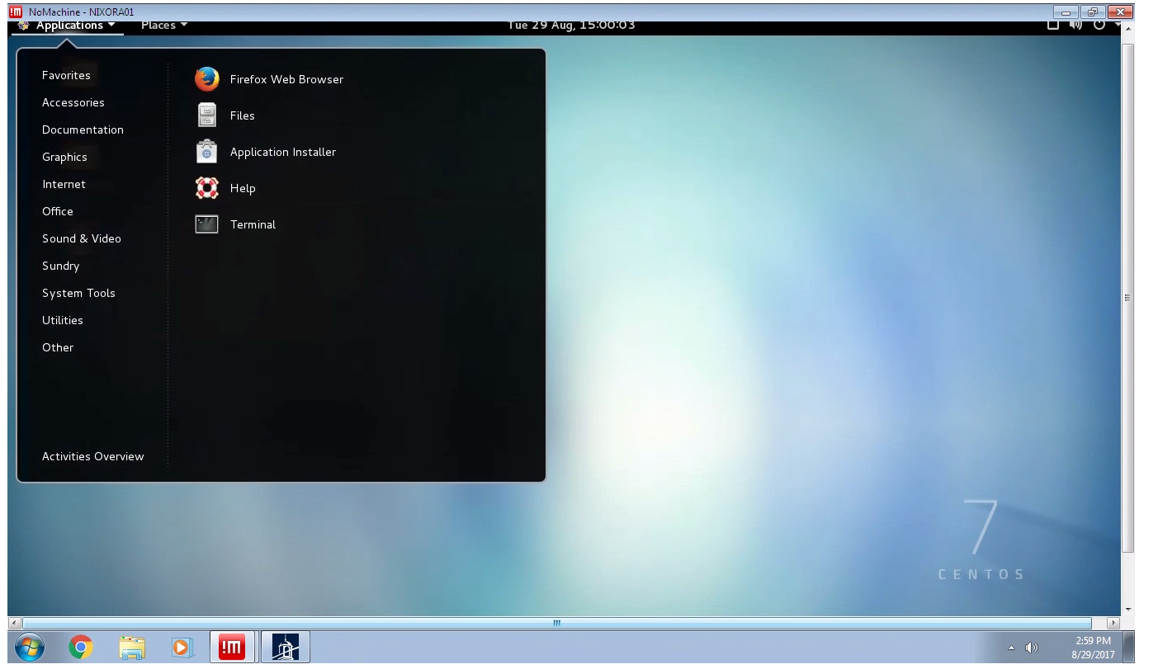

Now you have the GUI terminal below.

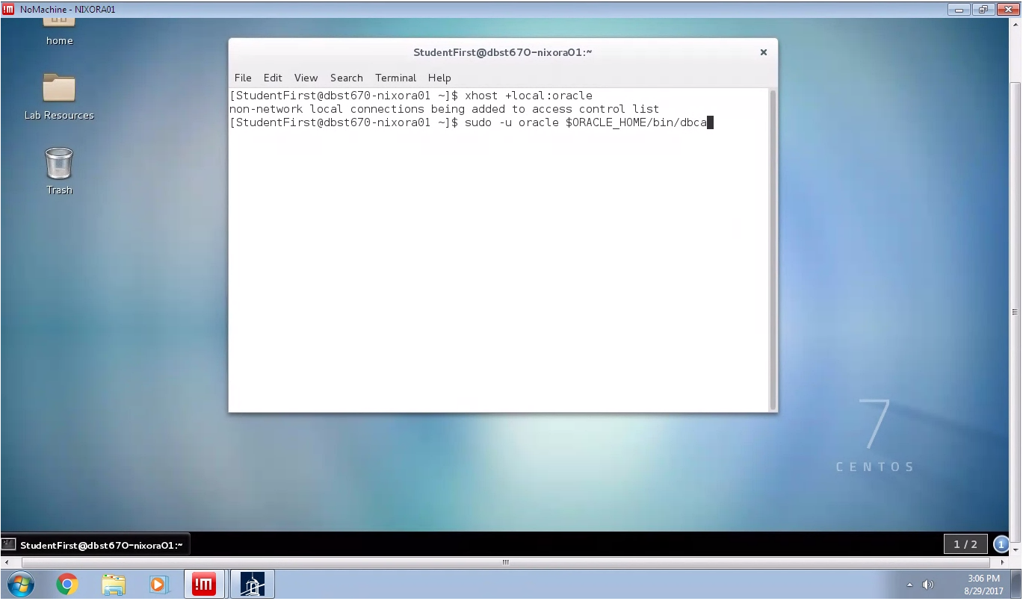

To run the installer using DBCA, execute the following on the terminal as show:

$ xhost +local:oracle

$ sudo -u oracle $ORACLE_HOME/bin/dbca

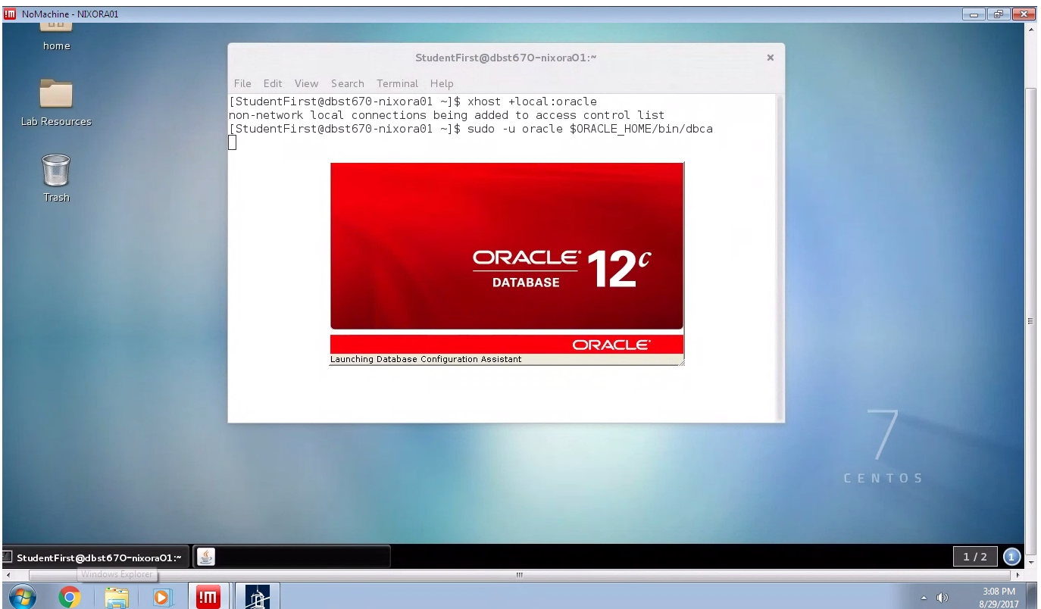

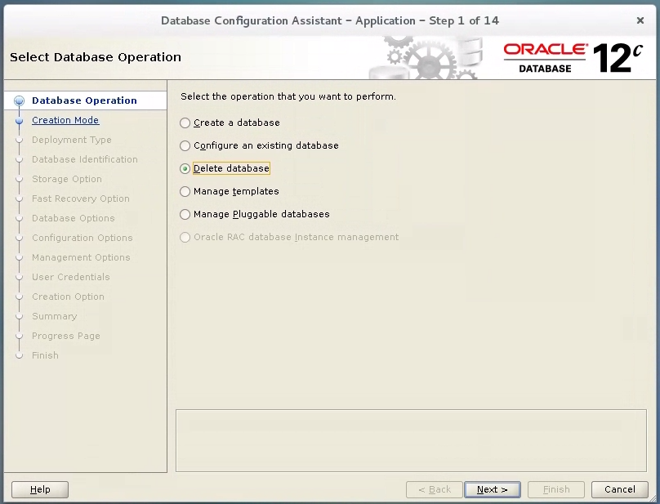

Select the delete database option to drop the existing database DBST670, and to clean your environment. Click Next to continue.

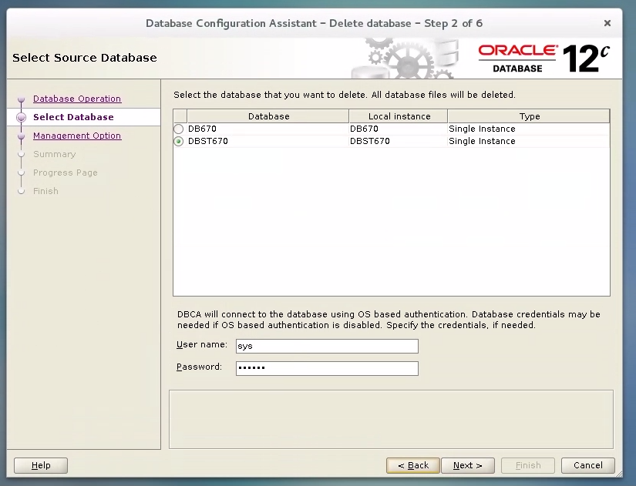

Select Source Database DBST670, enter USER NAME as: sys and password as 0racl3Adm1n , click Next to continue.

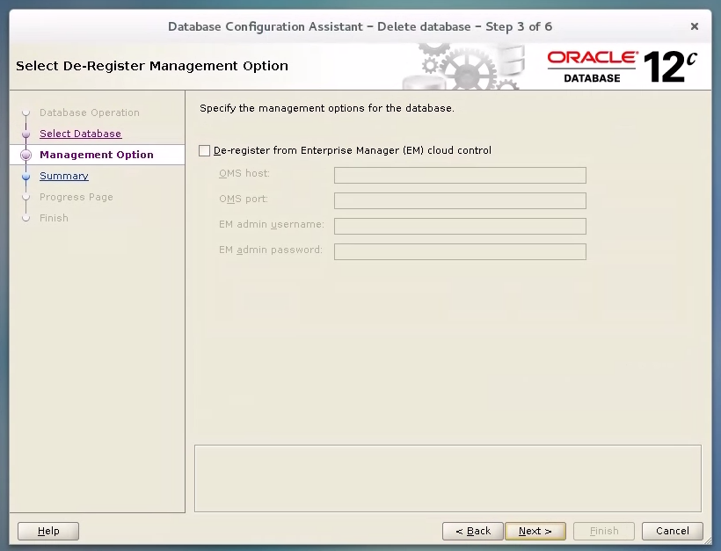

If the De-register from Enterprise Manager (EM) cloud control is checked, please uncheck it, and click Next to continue.

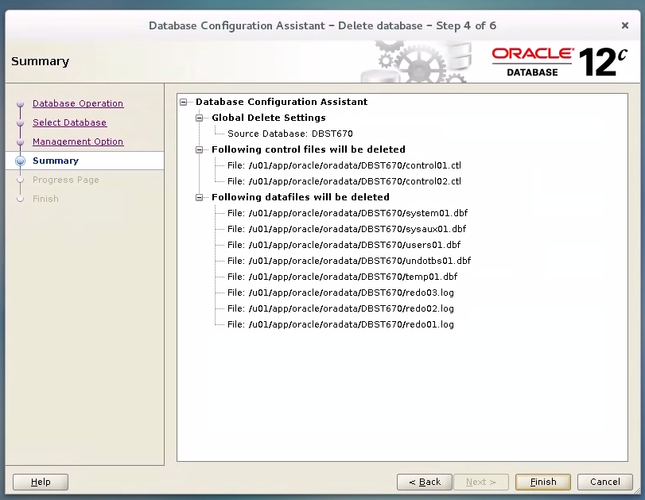

Click Finish to drop the database.

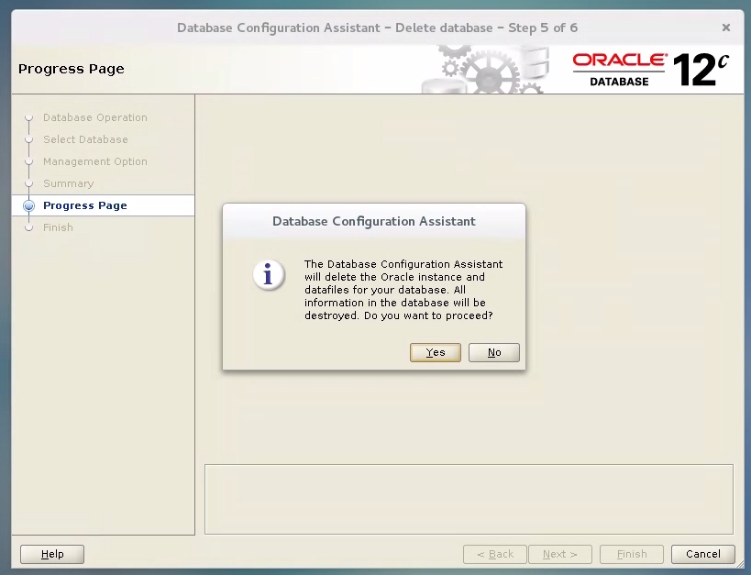

Click Yes to continue.

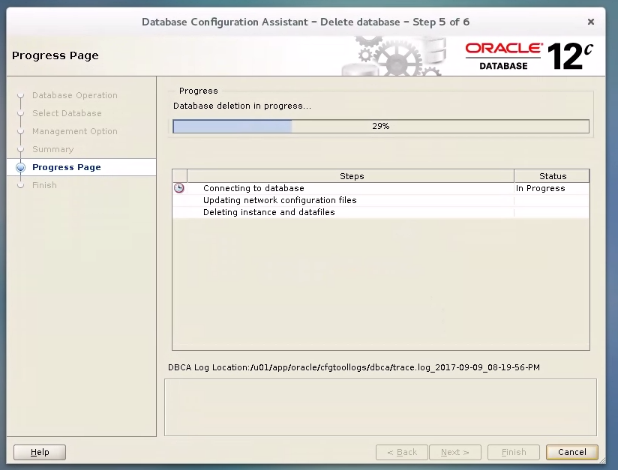

Wait for the process to complete.

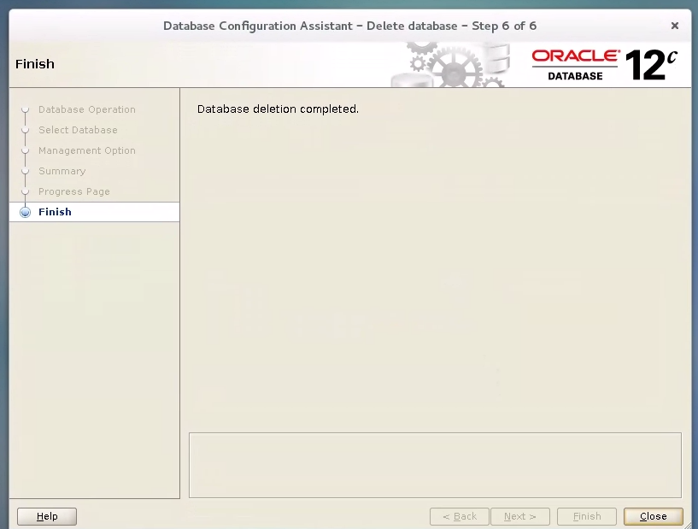

Click close. The existing database DBST670 is now completely dropped, and now you are back to the terminal.

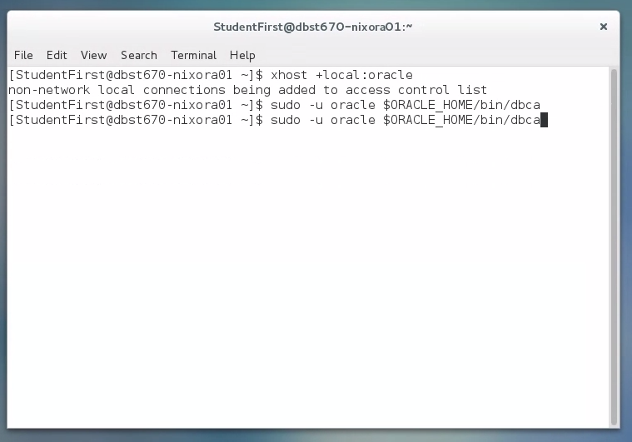

$ sudo -u oracle $ORACLE_HOME/bin/dbca

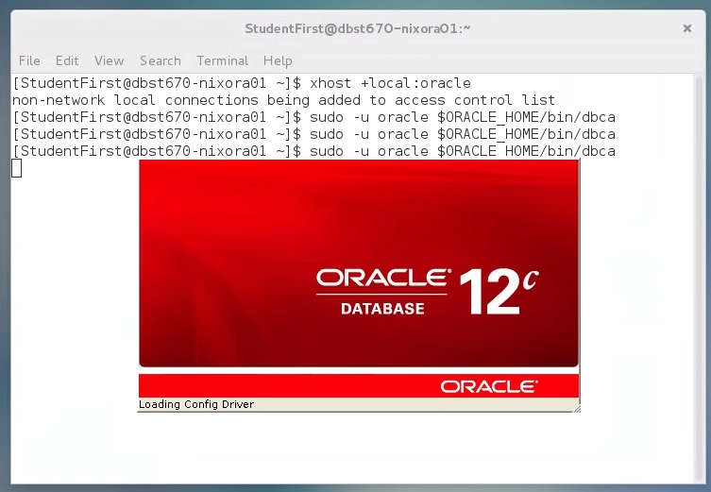

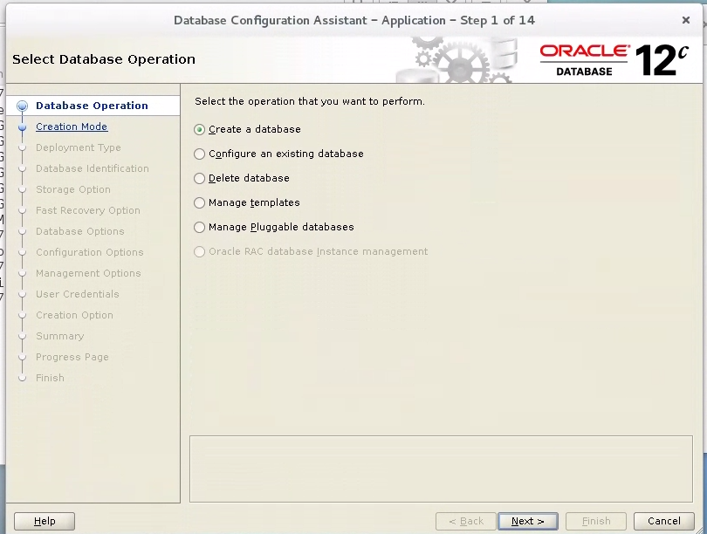

Select “Create database” if not already selected and click Next.

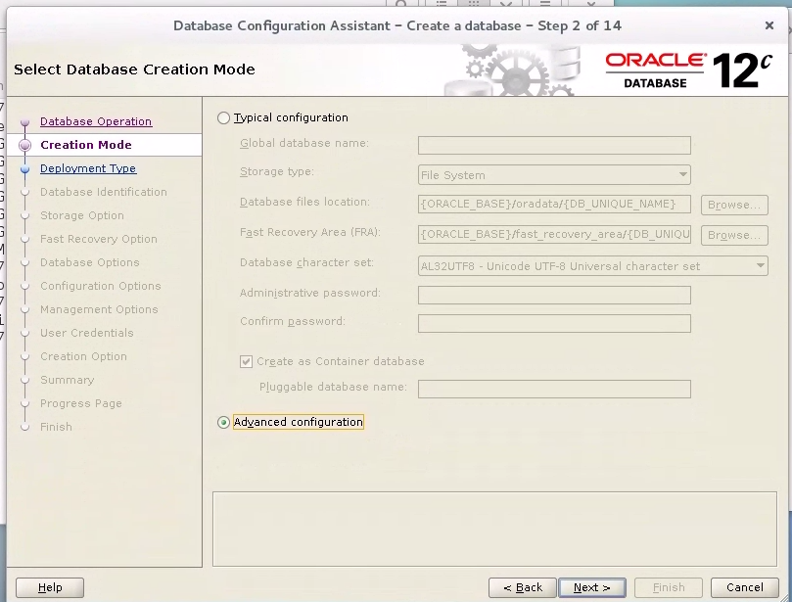

Select radio “Advance configuration’’ and click Next

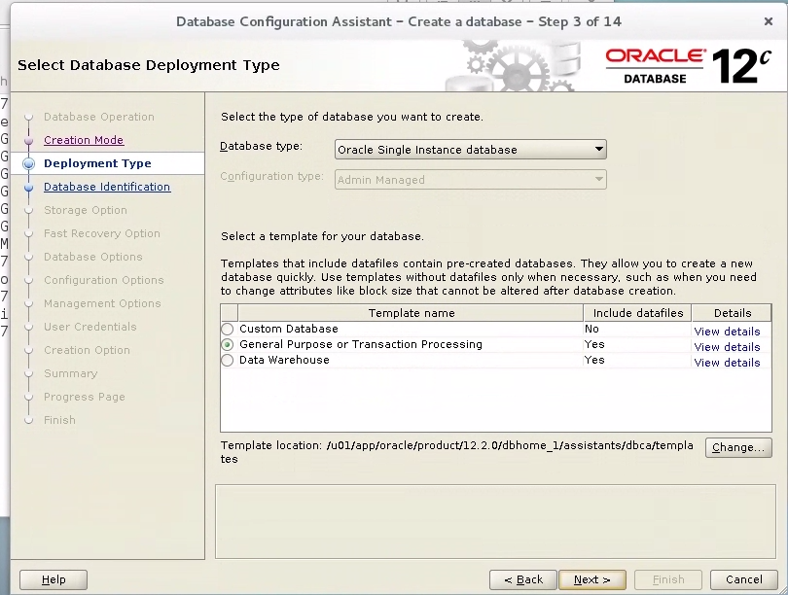

Select a template for your database, in your case select

* General purpose or Transaction Processing
* Click Next

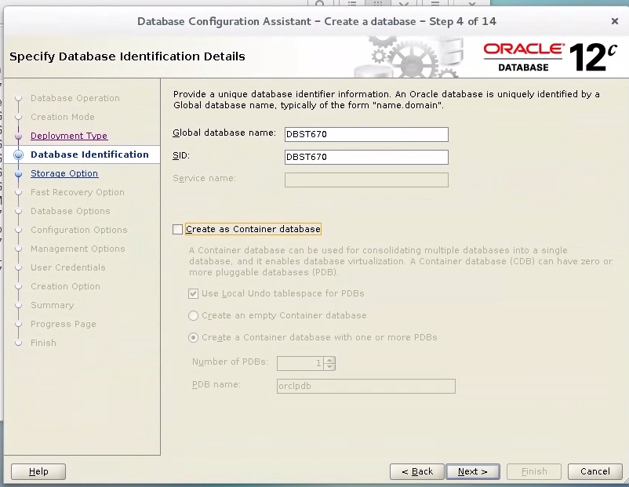

Provide a Global Database name –E.g. DBST670, and it will fill in the SID field for you.

Note: Please uncheck the Create as Container database radio button

Click Next

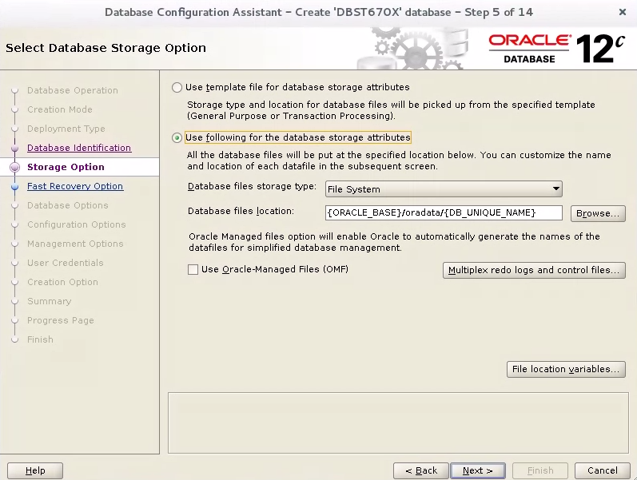

Click next

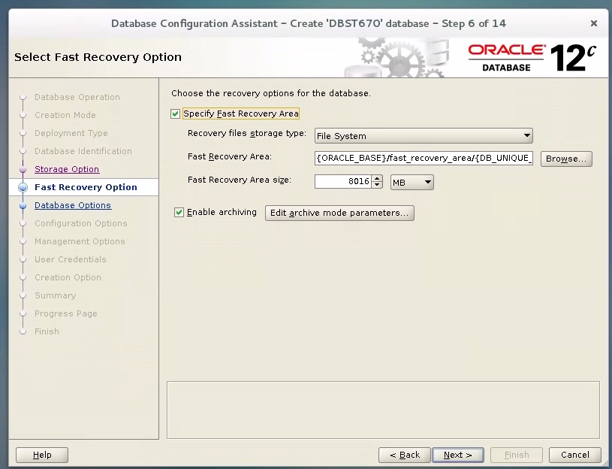

Check the following:

* Specify the recovery option for the Database
* Enable archiving

Notes: Click Next to continue

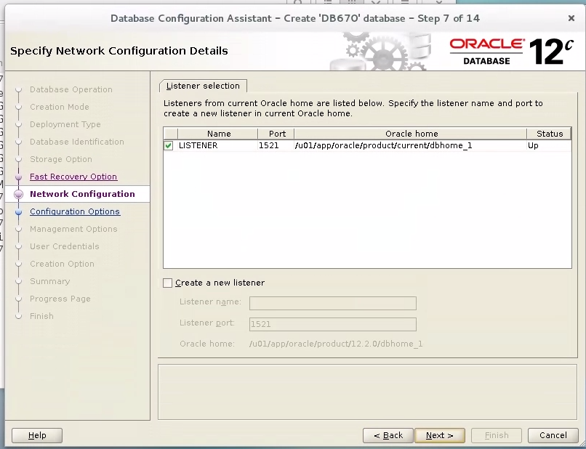

Here in my case, I already have an existing database instance and a LISTENER. I therefore choose to use the existing listener.

Note: If no LISTENER exists, choose the Create a new listener radio button, and accept the default LISTENER port of 1521. Click Next to continue.

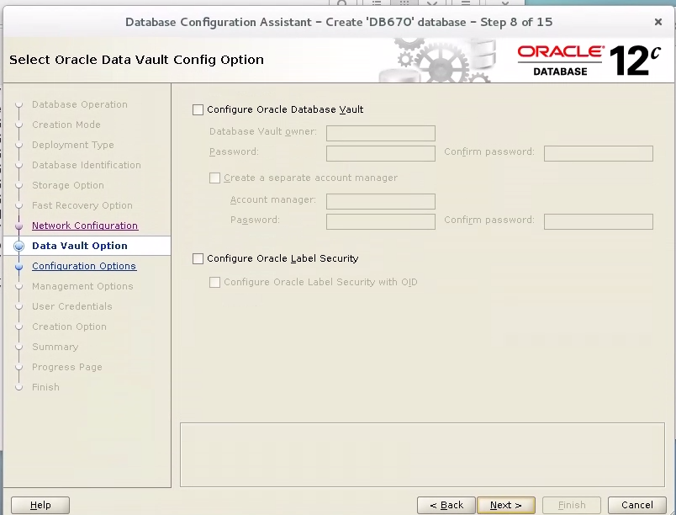

Uncheck the following: if already checked

* Configure Oracle Database Vault
* Configure Oracle Label Security

Click Next to continue.

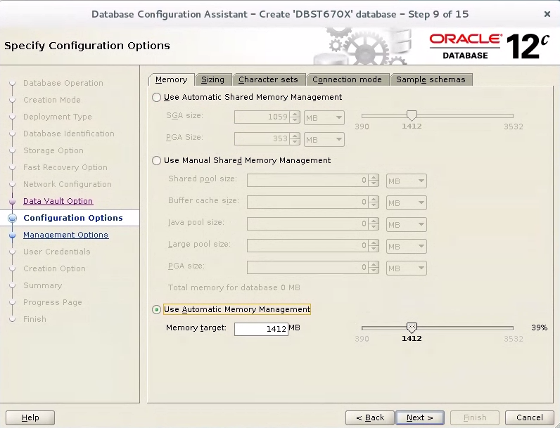

Here in this template, under the Memory tab,

* Make sure check Use Automatic Shared Memory Management, accept the SGA & PGA default size
* Uncheck Use Manual Shared Memory Management and Use Automatic memory Management

Click on the Sizing TAB

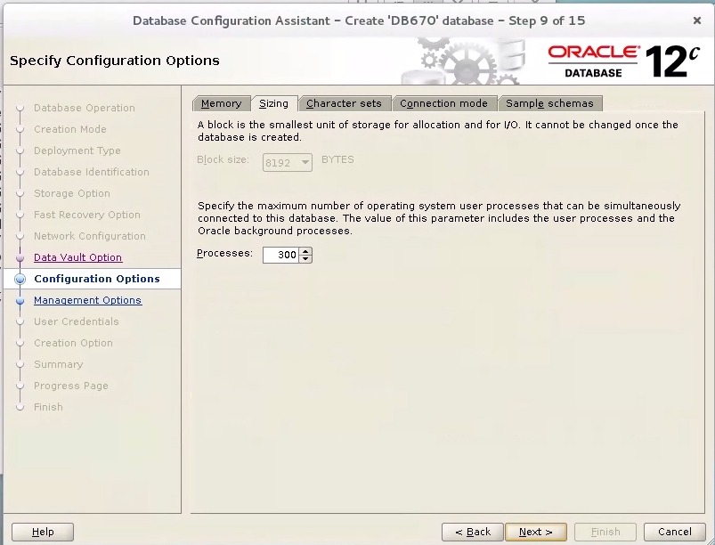

Accept all default value, and click Next.

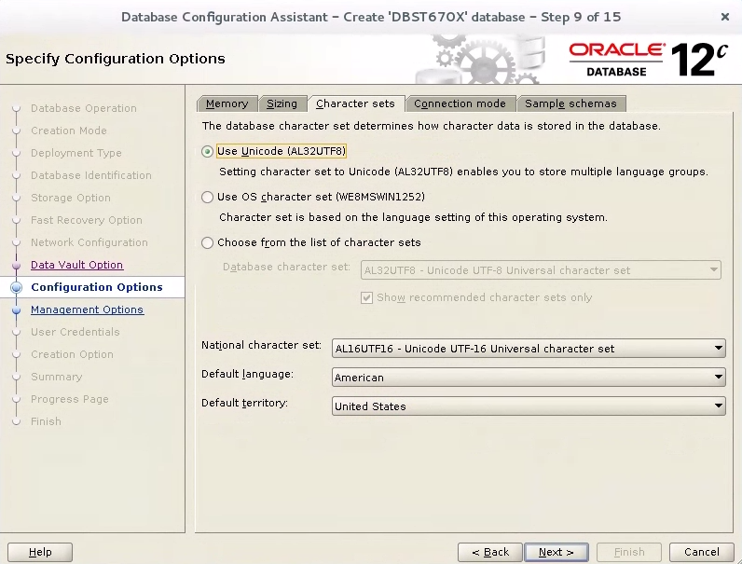

On the “Character Sets” Tab,

* Accept the rest of the default values, and click Next

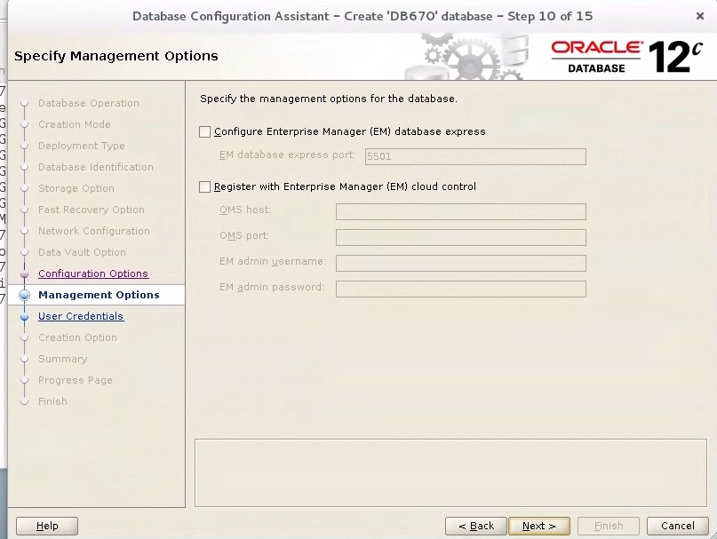

Accept all the default values unchecked as above, and click next to continue.

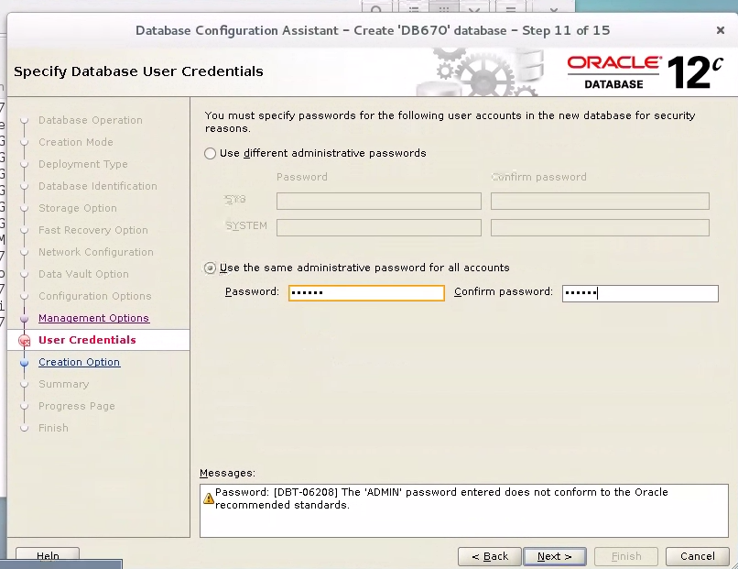

On the Specify Database User Credentials,

* select the “Use the same administrative password for all accounts”
* Enter your chosen password and confirm password values. Please use “sysdba” for both values for simplicity.

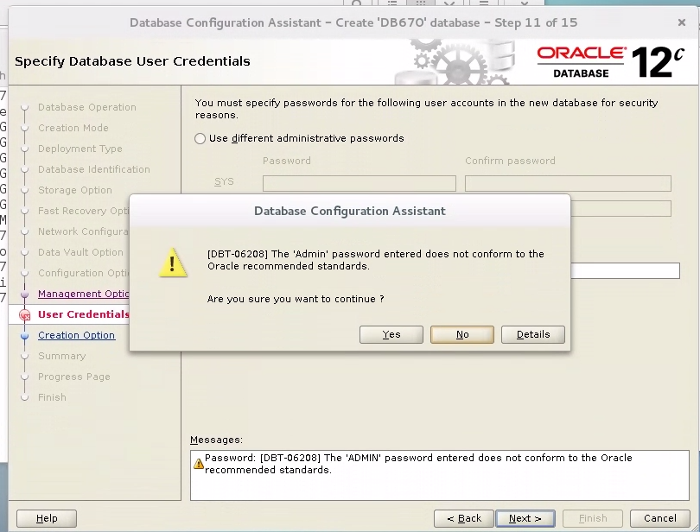

Please ignore this warning and click “Yes” to continue

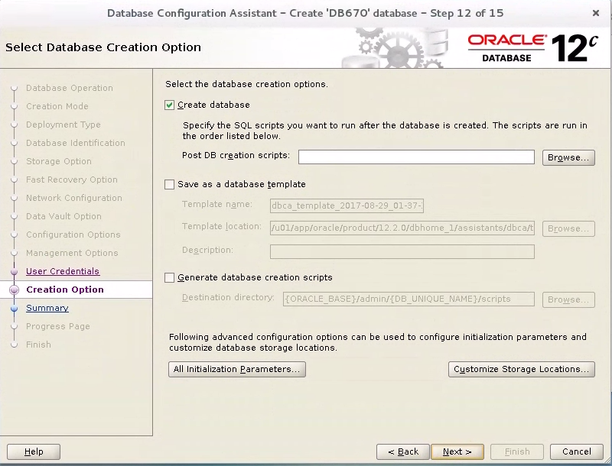

Click “Customize Storage Locations” to specify the datafile location on the Linux server

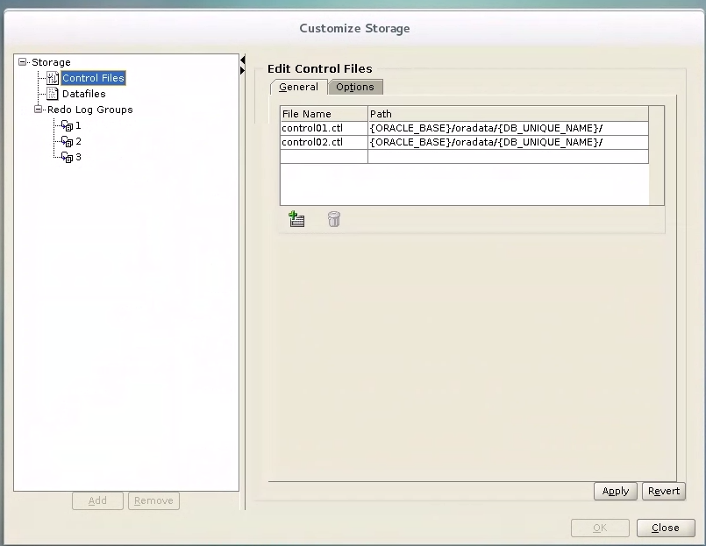

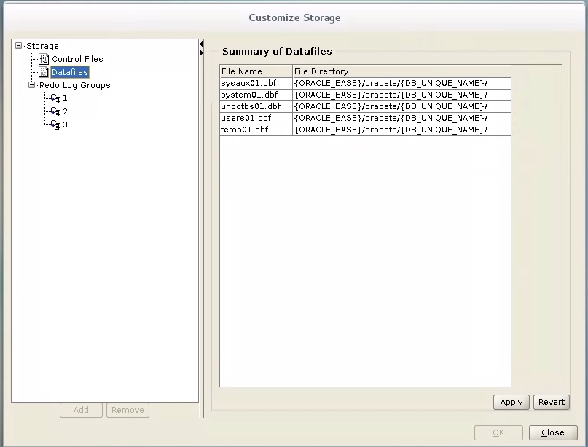

Accept all default locations, and click apply

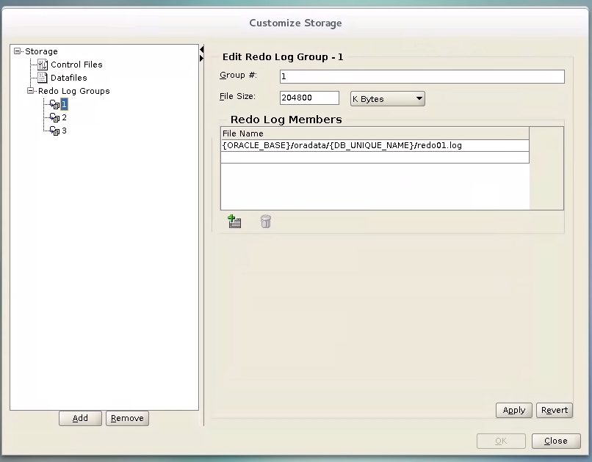

Accept all default locations, and click apply

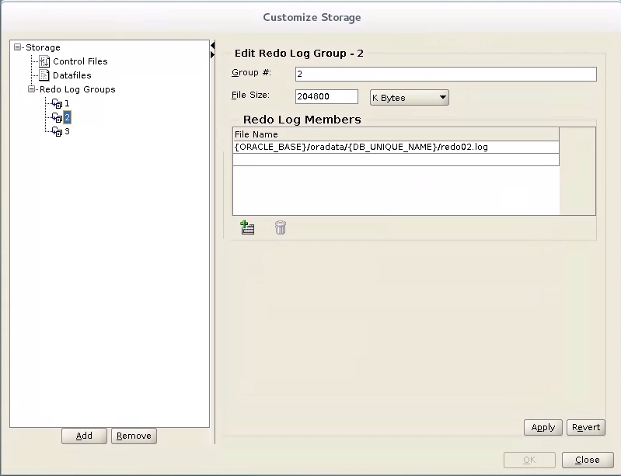

Accept all default locations, and click apply

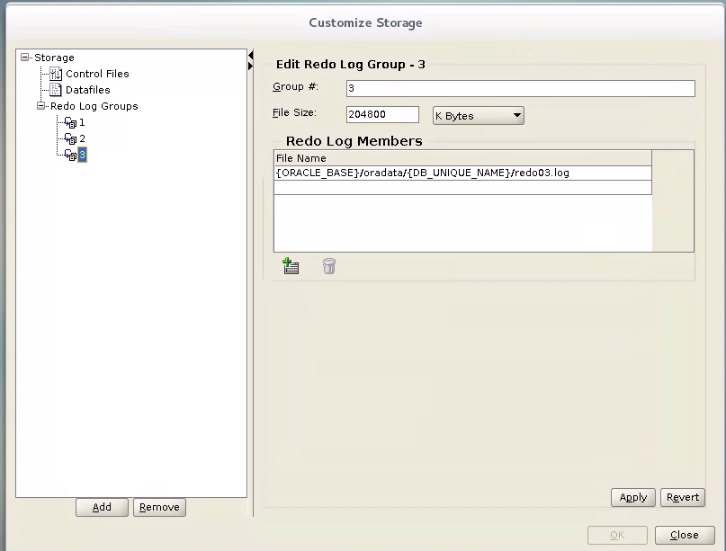

Accept all default locations, and click apply

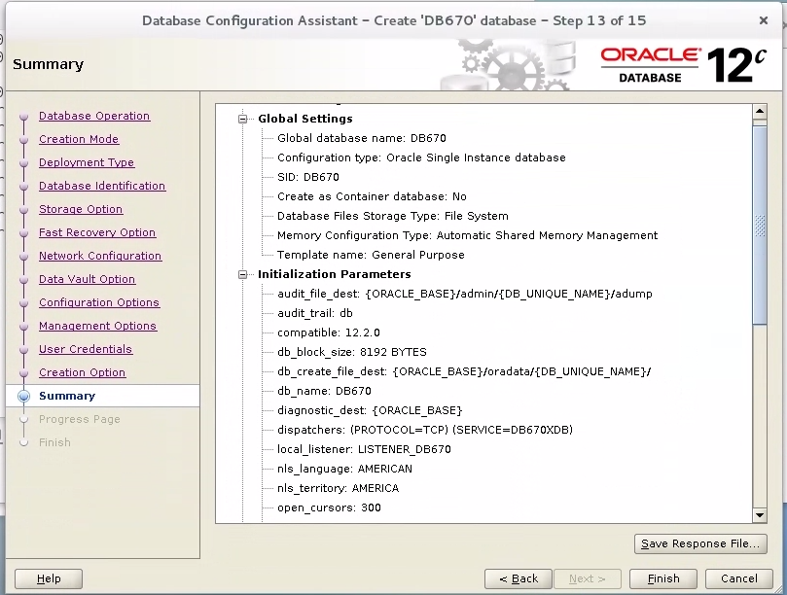

Click Finish to install the database.

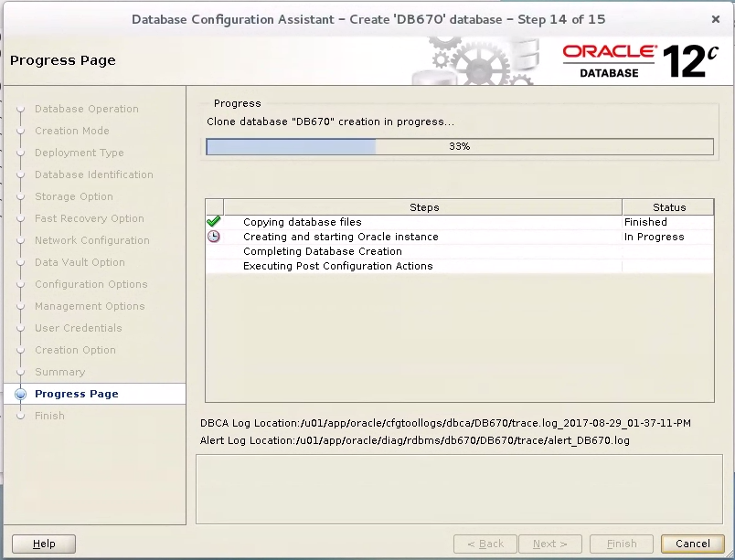

Waite for the database creation process to finish

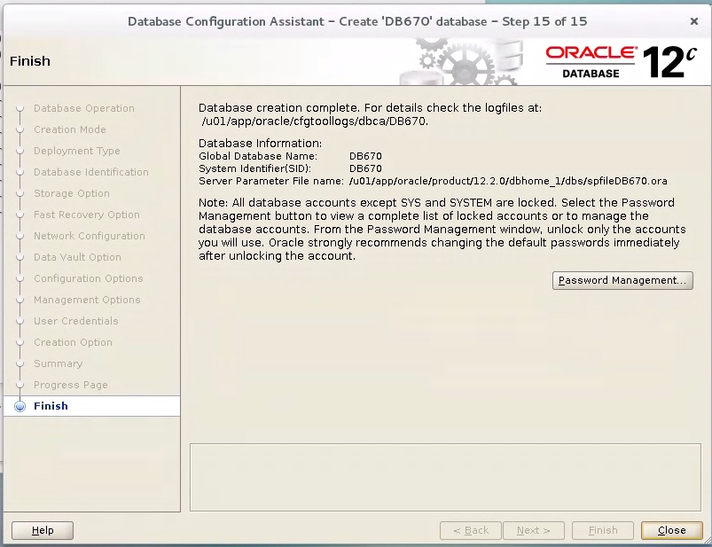

Click close

Now test to make sure your database is created by doing the following- see below

On the GUI, open a terminal and sudo as oracle user

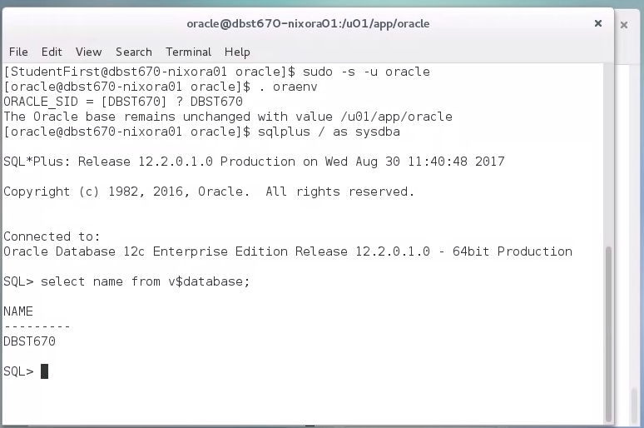

OR from your putty session

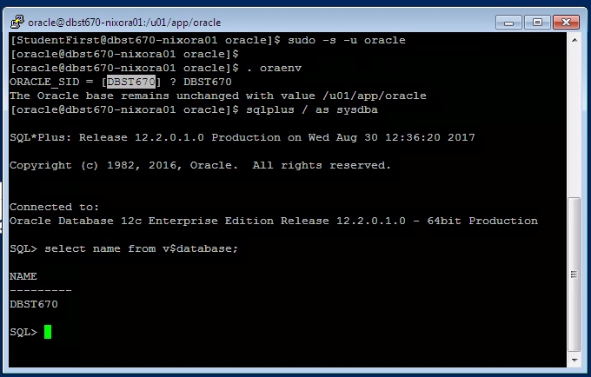

* Backup database using rman

Exit sqlplus and log on to rman From Unix prompt

**rman target /**

issue -

Backup database plus archivelog ;